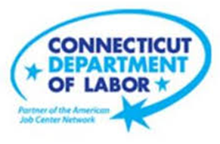

**NEW WEEKLY JOB POSTINGS FROM   
HELP WANTED ONLINE  
Office of Research**

**Week Ending October 28th, 2023: Total New Ads Down 932 Over The Week**  
WETHERSFIELD, October 31rd, 2023 – During the week ending October 28th, there were 5,171 new job postings in Connecticut. This total new ad count is down 932 from a week ago. Sixteen of twenty-one industries had over-the-week decreases, one was unchanged, and four increased. Some of the largest decreased include Professional, Scientific, and Technical Services (-170 new ads), Information (-59 new ads), and Educational Services (-56 new ads). The largest employer declines in those three indusutries respectively were KPMG (-17 new ads), Spectrum (-15 new ads), and Three Rivers Community College (-9 new ads). The three occupations with the largest over the week decrease were Laborers, Freight, & Material Movers (-45 new ads), Tractor-Trailer Truck Drivers (-41 new ads), and Stockers & Order Fillers (-34 new ads), all of which relate to the Transportaiton & Warehousing Industry. The graph below illustrates overall new ads count statewide from July Through October. During the four weeks ending in October, total new ads have averaged 5,663 per week and ranged between a low week of 4,820 new ads (10/14/23) and a high of 6,558 new ads (10/7/23).  
  
 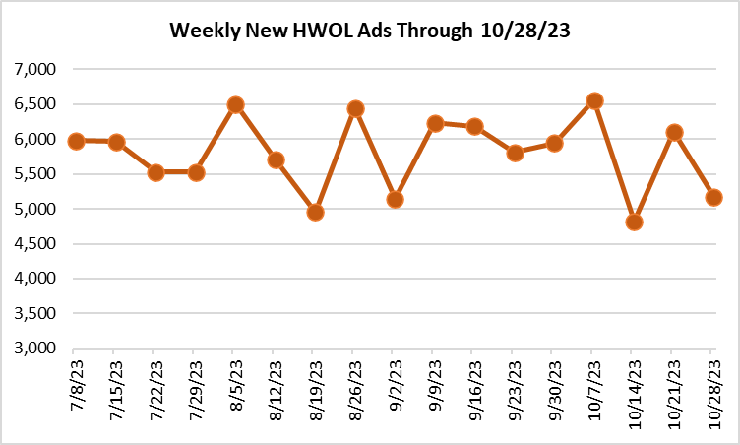  
  
  
  
**Industries** with the most new postings include Health Care & Social Assistance, Retail Trade, Manufacturing.

**Occupations** with the most new postings include Registered Nurses, Retail Salespersons, and Supervisors of Retail Sales Works.

**Employers** with the most new postings include Hartford Healthcare, Yale New Haven Health, and Trinity Health.

**New Weekly Job Postings by Industry**  
**The three industries with the most new job postings were:**

* **Health Care & Social Assistance** (977 new postings, -3% over the week)
* **Retail Trade** (540 new postings, +5% over the week)
* **Manufacturing** (476 new postings, -2% over the week)

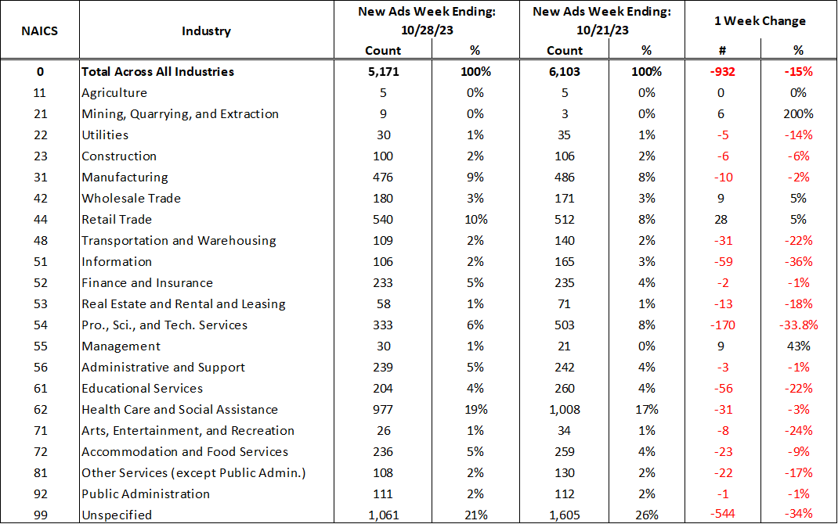

For more information on total monthly job ads in Connecticut and its labor market areas, see the monthly report available here: <https://www1.ctdol.state.ct.us/lmi/hwol.asp>

 The above table highlights the 25 occupations with the most new job ads during the week ending October 28st, 2023. During that week, employers posted new job ads for over 700 specific occupations in the state. The 25 occupations account for 42% of the 5,171 new ads during the week. The three occupations with the most new ads were Registered Nurses (377 new ads), Retail Salespersons (191 new ads), and Supervisors of Retail Sales Workers (137 new ads). Among job ads with advertised salary information, these three occupations had respective median advertised annual incomes of $86,272 per year, $37,504 per year, and $51,968 per year. Among the 25 occupations with the most new ads, the median annual salary ranged from $33,920 (Fast Food and Counter Workers) to $170,752 (Sales Managers).

**Employers with the Most New Job Postings**    
Employers with the most new job postings during the week ending October 28th, 2023 were mostly within Healthcare, Retail Trade, and Finance & Insurance. The employers with the most ads in those respective industries were Hartford Healthcare (195 new ads), CVS Health (54 new ads), and The Hartford (30 new ads). Twenty-one employers in the top 25 had over the week new ad increases and four declined. The largest over-the-week increase among the 25 employers occurred at Trinity Health (+66 new ads) and the largest decrease occurred at ASML (-13 new ads).   
 **What is HWOL?**The **Conference Board Help Wanted Online**® Data Series (HWOL) measures the number of new, first-time Online job postings and jobs reposted from the previous month for over 16,000 Internet job boards, corporate boards, and smaller job sites that serve niche markets and smaller geographic areas. To view more HWOL data, go to: <https://www1.ctdol.state.ct.us/lmi/hwol.asp>